1)Assume each salesperson has a 12% commision. Write a query on the orders table that will produce the order number, the salesperson number and the amount of salesperson’s commision for that order.

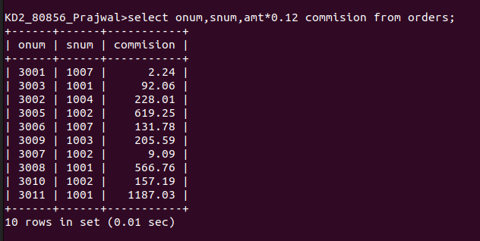

2) Write a querry on the customers table that will find the highest rating in each city.
Put the output in the from: For the city (city) , The highest rating is : (rating)

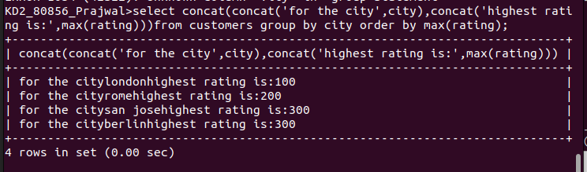

3) Write a query that lists customers in descending order of rating. Output the rating field first, followed by the customer’s name and number.

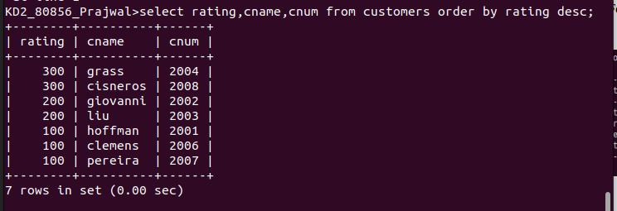

4) Write a query that totals the orders for each day and places the results in descending order.

